BUFFALO RIVER WATERSHED ALLIANCE
PO Box 101, Jasper, AR 72641
(870) 446-5783 buffalowatershed@gmail.com

Comments on Regulation 6 and Regulation 5 Revisions

Submitted via electronic delivery to http://water.adeq.commentinput.com/?id=6pAef
January xx, 2020

These comments are submitted by the Buffalo River Watershed Alliance regarding proposed revisions to APC&EC Rule 5 Liquid Animal Waste Management Systems, Markup Draft July, 2019 and APC&EC Rule 6 Regulations for State Administration of the National Pollutant Discharge Elimination System (NPDES), Markup Draft July, 2019.

The following are intended as addendums to comments submitted on September 23, 2019 during the previous 30-day comment period regarding these same revisions and we hereby incorporate those comments in their entirety by reference. These comments primarily focus on the Big Creek Research and Extension Team Final Report and on proposed Rule 5.901 and Rule 6.602. Also included below are excerpts from two reports prepared by Dr. Mike Smolen, Ph.D, an acknowledged expert in water quality and agricultural waste management. Both reports are attached to these comments in their entirety and should be considered as part of our comments.

We fully support the proposed changes to Rule 5.901 and Rule 6.602 prohibiting the issuance, reissuance or modification of permits for medium and large swine CAFOs in the Buffalo National River watershed.

Summary
The Big Creek Research Extension Team’s (BCRET) final report (https://bigcreekresearch.org/project_reports/) in spite of numerous errors and apparent obfuscation, nevertheless clearly documents, after only 5 years of operation, water quality impacts from a single hog concentrated animal feeding operation (CAFO) in the Buffalo National River Watershed. Such facilities are designed for a much longer operational life. In this case, C&H Hog Farm had an initial 12-year contract and likely would have remained operational for a much longer period if not for the closure of the facility. The documented impacts as detailed below would have grown exponentially if, 1) C&H had been allowed to operate until the end of its design life, and/or, 2) additional medium or large swine CAFOs were permitted in the watershed. Statements and data from the BCRET report, and the conclusions of the expert panel review of the BCRET report, along with the two expert reports attached to these comments, all reveal impacts and advise caution regarding management of swine waste from C&H and warn of the potential impact of other such facilities in the watershed, thus supporting the need for a permanent moratorium on swine CAFOs in the Buffalo National River watershed in order to protect this extraordinary resource water and state and national icon.
It must be noted that this 90-day comment period was opened ostensibly to allow for comments on the BCRET final report, released after the previous 30-day comment period had closed. While our comments here reference the BCRET report, we contend that the BCRET final report is so rife with errors that the accuracy and reliability of its entire contents and conclusions are called into serious question. Even the expert review team did not identify numerous errors which only came to light due to careful review by concerned citizens who brought errors to the notice of the BCRET team. Some of these errors are noted below. Some have been corrected in the revised report but others persist. Below in Part 1 are examples of impact to soil and surface and groundwater from operation of the C&H Hog Farm, quoting from the BCRET final report. There follows in Part 2, excerpts from two reports prepared by Mike Smolen, Ph.D, an acknowledged expert in water quality and agricultural waste management. Both reports are attached to these comments in their entirety as part of our comments.
Part 1: Evidence of Impact shown in BCRET Final Report

- Application of hog waste onto Buffalo River watershed fields has resulted in phosphorous overloading. (See page 10 explaining consequences of Legacy Phosphorus and pages 4-6 for graphs from BCRET)

"Future additions of any nutrients (i.e., as mineral fertilizer, swine slurry, or poultry litter) to fields, which received slurry from C&H Farms, should be carefully managed, so as not to lead further increases in soil test P. {7}

BCRET graphs show: Significant increase in nitrates and phosphorous downstream from C&H{2}

- Karst geology in the watershed leads to significantly increased radius of contamination transport
“The Big Creek Watershed below the C&H Farm and application field locations, lie within a karst hydrologic system of great complexity exhibiting intimate connection of surface-water and groundwater regimes. These characteristics endow the hydrologic system as an important recreational resource locally and regionally, but also render the system vulnerable to contamination.” {3}
- Impaired status of Buffalo River and Big Creek
Using BCRET and other water sample data, 19 miles of Big Creek and 14 miles of the Buffalo, at the confluence of Big Creek, were declared 303(d) impaired in 2018. {4} See map on page 9 of this document.

- Nitrates and Phosphorous increases in Big Creek
BCRET acknowledges statistically significant changes in nitrates and phosphorus downstream from C&H:
“Phosphorus and N concentrations in Big Creek were greater downstream than upstream of the C&H Farm. For example, the 5-year mean nitrate-N concentration was 0.13 mg/L at the upstream site and 0.29 mg/L at the downstream site.”

BCRET initially illustrated the downstream increase in nitrate and phosphorus very clearly with the following graphics in Chapter 7, “Nutrient Loads Upstream and Downstream of C&H” {2}:
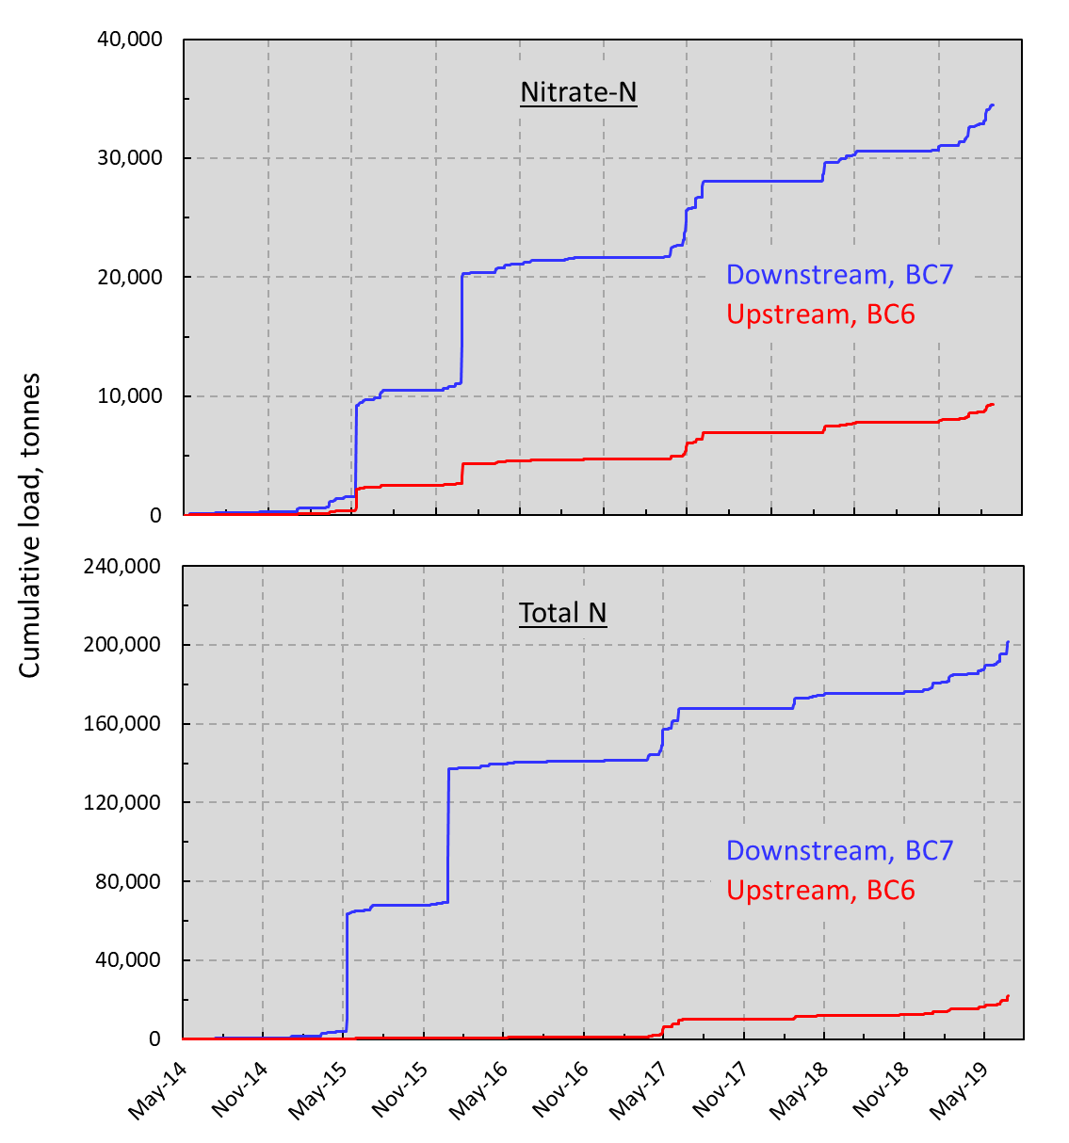
Figure S 11. Cumulative nitrate-N and total N load up (BC6) and downstream (BC7) of the C&H Farm on Big Creek with extreme May and December 2015 storms included.

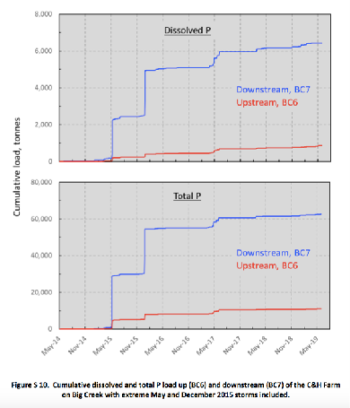
However, after completing the expert review, and after posting the final report, BCRET was alerted to errors, most notably in Chapter 7 and subsequently a revised version was uploaded with this message: “A coding error in Loadest was corrected and the resulting nutrient loads determined are provided in the section “Nutrient Loads in Big Creek Up and Downstream of C&H Farm 12-31-19 Revised” of the Final Report.” The revised charts now appear as shown below. {6}
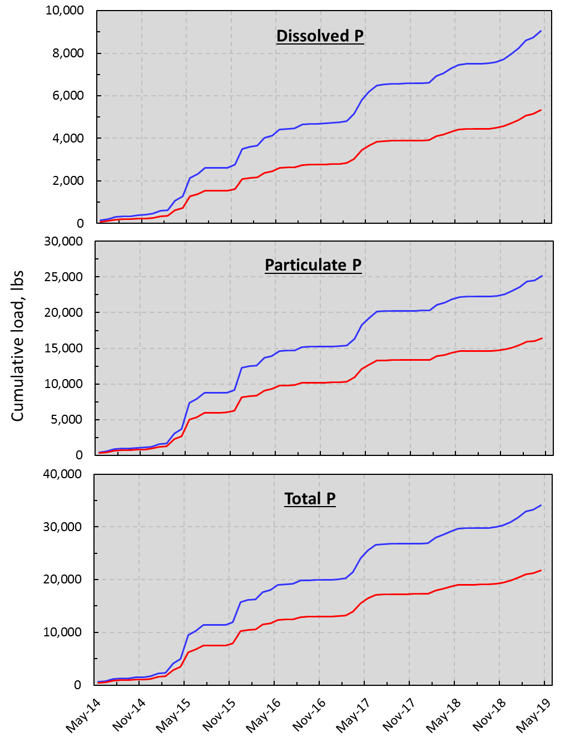 Figure S 6. Cumulative dissolved and total P load up- (BC6) and down-stream (BC7) of the C&H Farm on Big Creek.
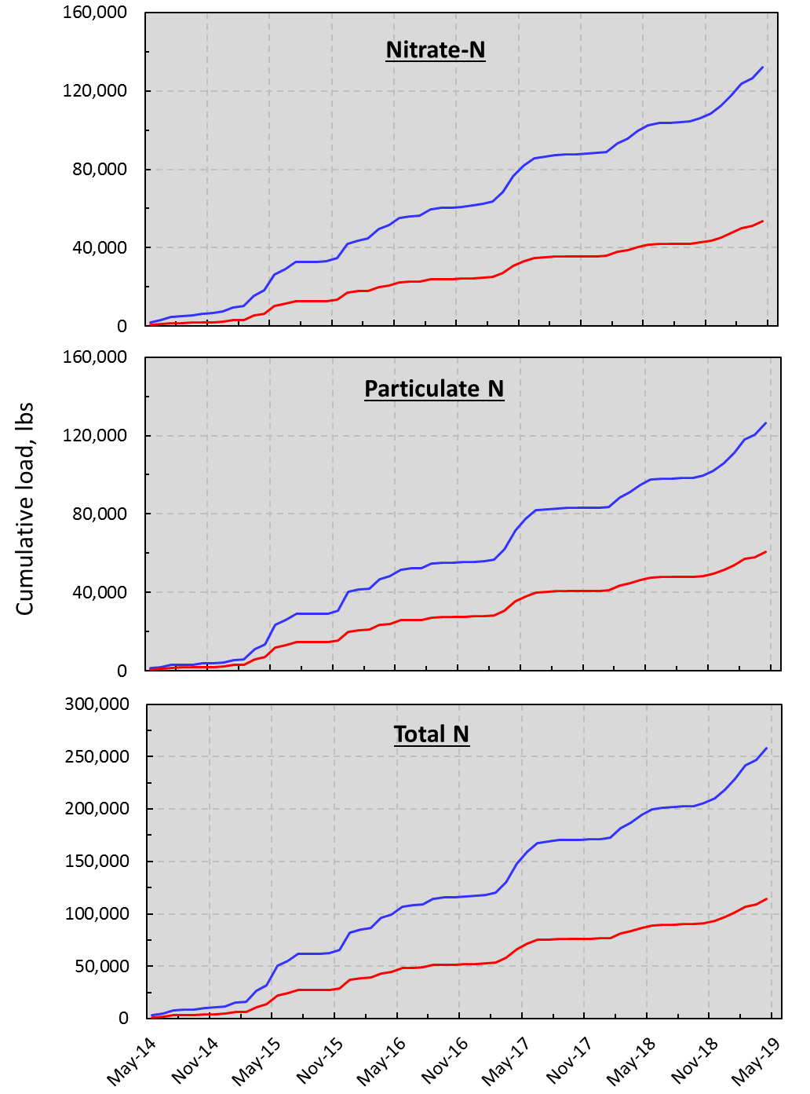
Figure S 7. Cumulative nitrate-N and total N load up- (BC6) and down-stream (BC7) of the C&H Farm on Big Creek.

The errors were said to be due to “accounting” and “coding” problems and, while there was little effort to interpret the results, even the revised charts reveal 2 important facts:
- At the beginning of the testing period, in May, 2014, there was little difference between upstream and downstream levels of nitrate and phosphorus with very low levels of both nutrients detected. May, 2014 correlates with the beginning of field application of swine wastes by C&H.
- 5 years later, at the end of the testing period in May, 2019, there was a significant upstream vs downstream difference, with approximately 6 tons more Total P loading and 75 tons more Total N downstream than upstream.

Even after correction, this data indicates that C&H is contributing substantially to the cumulative N and P loading in Big Creek.

- Impact seen at sites adjacent to production facility and holding ponds BCRET acknowledges that measurements in the House Well suggest contamination.

“There was a statistically significant (probability <0.0001) increase in nitrate-N concentrations in well samples … over the monitoring period (April 2014 to June 2019) …”

BCRET acknowledges that measurements in the ephemeral stream suggest contamination.

“There was a statistically significant (probability <0.0001) increase in nitrate-N concentrations in ephemeral stream … over the monitoring period (April 2014 to June 2019) …” {9}

Clay holding pond leakage - Engineering estimates
Construction of clay ponds assume leakage. The original engineer (Nathan Pesta) conducted tests and calculations to estimate the leakage.
Pond 1 calculated seepage rate per acre: 3448 x .4788 acres = 1651 gallons leaked per day
Pond 2 calculated seepage rate per acre: 4060 x .8095 acres = 3286 gallons leaked per day Total seepage for 1.288 acres = 4,938 gallons per day.

Runoff
BCRET acknowledges runoff risk of P and N but notes that, without baseline information, increases during the study cannot be known. This deficiency shows a significant flaw in the BCRET study.
“Grazing, slurry, and fertilizer management of Fields 1, 5a, and 12 over the 5 years of monitoring, may have resulted in an increase in the potential loss of P and N to Big Creek.” {9}
The graphics referenced on pages 5 and 6 above indicate that N and P losses to Big Creek are in fact occurring.

Storm events and unavoidable runoff
BCRET notes that over 5 years, C&H experienced two major flooding events with significant run-off and that conservation practices are ineffective in preventing such runoff in the future.

“The two largest storms occurring during each of the 5-year monitoring accounted for 44, 49, 37, and 42% of the total 5-year load of dissolved P, total P, nitrate-N, and total N, respectively, and 43% of discharge measured at BC7. At the upstream site (BC6), these same storms comprised 45, 47, 42, and 44% of dissolved P, total P, nitrate-N, and total N load, respectively, and 43% of total discharge. During these large storm events, the monitored application fields BC5a and BC12 were mostly flooded as Big Creek breached its banks. Thus, the effectiveness of conservation practices, such as buffer strips or no-application zones for slurry would have little impact on the conservation of nutrients or limiting their movement to Big Creek, under such extreme flow events.” {8}

Thin soils present subsurface contamination risk
BCRET tested three fields noting soil depths. Two fields had severe limitations (20” or less in depth) due to thin soils per USDA guidance and the third had moderate limitations (40” or less). All fields are underlain with epikarst. {12}

Karst significantly increases radius of contamination transport
BCRET acknowledges the entire area is underlain by karst:
“The Big Creek Watershed below the C&H Farm and application field locations, lie within a karst hydrologic system of great complexity exhibiting intimate connection of surface-water and groundwater regimes. These characteristics endow the hydrologic system as an important recreational resource locally and regionally, but also render the system vulnerable to contamination.” {10}

BCRET references work by Kosič demonstrating complexity of karst.
”The dye-trace studies of Kosič (2019) and Kosič et al. (2015) demonstrate the high velocity with which groundwater flows can occur in the Boone karst setting of Big Creek Watershed (Table 1 and Figures 4, 5, and 6). It was evident from the eosin-dye injection that subsurface flows traversed surface drainage basins, with detects from the field adjacent to BC12 occurring in Left Fork sub watershed (Figure 6). The overall conclusions of the dye-trace studies of Kosič (2019) demonstrate the complexity of subsurface flows in the karst system in this area of the Boone formation. {11}

Shown below:
The impaired segments of the Buffalo River and Big Creek (draft 303d list), correlate closely with the dye trace conducted by Dr. Van Brahana. Dye injected at Mt Judea, in close vicinity to the C&H spreading fields, makes its way into the Buffalo, not just at the mouth of Big Creek, but a considerable distance both upstream and downstream as well. This shows the possibility that a single waste source of a large size in a karst location, such as C&H Hog Farms, could very well contribute to impaired waters throughout the area.

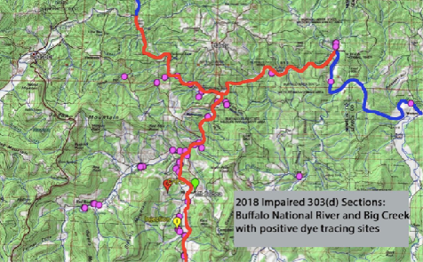

What is Legacy Phosphorous ?
Legacy Phosphorus is the phenomenon whereby excess phosphorus is stored in the soil profile and is released to waterbodies, including groundwater, slowly or intermittently over long periods of time.
Since 2013, raw swine sewage has been stored in two waste ponds, with 2.5 million gallons spread each year onto fields in the Buffalo National River watershed. Fields have received far more nutrients than vegetation potentially can absorb, and the soil has become heavily saturated with stored phosphorous. Now that the CAFO is closed and the spraying halted, this “legacy phosphorous” will continue to leach into the underlying karst, and will be washed into surface waters through rain events. It contaminates groundwater and resurfaces in seeps and springs that feed Big Creek and the Buffalo River (see map above). Too much phosphorous causes algal blooms. The dye trace studies cited in the BCRET Final Report show how far and how quickly water can travel underground. Assessing and cleaning up what is left behind in the C&H soils will take many years and require persistence and monitoring.
In a 2013 article co-authored by the principle investigator of BCRET, Dr. Andrew Sharpley, the seriousness of legacy phosphorous is stated:
“. . . we face unprecedented challenges in meeting water quality targets, given that P legacies from past land management may continue to impair future water quality, over time scales of decades, and perhaps longer.” {5}

REFERENCES
1. BCRET Final Report, October 24, 2019, Executive Summary, pp. 6 & 7. C&H 2018 Hog Farm Annual Report.
2. BCRET Final Report, October 24, 2019. Chapter 7, pp. 30-31.
3. BCRET Final Report, October 24, 2019, Chapter 2, p.2.
4. Arkansas’s Final/ Draft Impaired Waterbodies – 303(d) list, 2018.
5. Water Quality Remediation Faces Unprecedented Challenges from “Legacy Phosphorus”, Helen P. Jarvie, Andrew N. Sharpley, Bryan Spears, Anthony R. Buda, Linda May, Peter J. A. Kleinman, Environmental Science & Technology, 2013, 47, 16, 8997 8998(Viewpoint)Publication Date (Web):August 9, 2013
6. BCRET Final Report, revised December 31, 2019, Chapter 7, pp. 29-31.
7. BCRET Final Report, October 24, 2019. Summary, p. 1.

8. BCRET Final Report, revised December 31, 2019, Chapter 7, Summary, p. 1.

9. BCRET Final Report, revised December 24, 2019, Executive Summary, p. 7.

10. BCRET Final Report, December 24, 2019, Chapter 2, p. 2.

11. BCRET Final Report, December 24, 2019 Chapter 2, p. 10.
- BCRET Final Report, December 24, 2019, Executive Summary, p. 6

Part 2: Expert Review of BCRET Quarterly and Final Reports
BRWA commissioned a review and expert opinion of the BCRET Quarterly Reports and October and December (revised) Final Reports by Dr. Mike Smolen, Ph.D, Environmental Sciences and Engineering, a highly qualified water quality and agricultural waste management specialist with Lithochemeia, LLC, Tulsa, Oklahoma. Attached to this submission are his “Preliminary Report: Critique of the BCRET Project Evaluating the C&H Hog Farm Impact on Big Creek”, November 7, 2019, as well as his “Comments on the BCRET Final Report”, dated January 17, 2020, from which we include excerpts below.
These expert opinions reveal to us that: 1) the BCRET 5-year study of C&H was largely inadequate, flawed and unreliable, with weak opinions and frequent obfuscations and is a poor basis upon which to judge the impact of C&H on ground and surface waters of the area, and 2) if, however, one filters through the errors and obfuscation and carefully considers what data is dependable, one sees a picture of irrefutable impact to the water quality of Big Creek. In spite of BCRET’s implications that C&H has had no significant impact, it is clear from the data that the continued operation of C&H, compounded with the possibility of other similar facilities in the watershed, is a recipe for disaster with the Buffalo National River bearing the brunt. A halt to the issuance of permits for such facilities, ie: a permanent moratorium, is required and is justified by the near-miss of C&H.
We adopt and submit the entirety of both of these attached reports as comments of BRWA. Below are some excerpts.
Excerpts from Dr. Mike Smolen’s Review of the BCRET Final Report, January 17, 2020
General Conclusion from review of the BCRET Final Report
The University of Arkansas research and extension team (BCRET) conducted five years of intensive monitoring and technical assistance education with the one and only large hog producer in the Buffalo River watershed (C&H Farms). The work clearly shows an increase in nutrient concentration in Big Creek and a well-documented increase in loading of Nitrogen and Phosphorus. The results suggest that continued operation of a single farm like C&H, even with the best technical assistance available will be damaging to the Buffalo River. The current moratorium on swine CAFOs should be continued, and in my opinion made permanent.
Concerns with Monitoring
The BCRET reports lack detailed Standard Operating Procedures for sampling and interpretation of sampling results and Quality Assurance documentation.
BCRET reports indicate that the field stations had prefabricated H-flumes installed, and the culvert on the ephemeral stream was used for flow control, but the upstream station, BC6, had no flow control and no traceable rating curve developed. Initial estimates of runoff and loading at BC6 and BC7 were seriously in error.
Even with the revisions, errors persist, making it difficult to trust some of the detail of the report. Runoff results from Field studies (Chapter 6) still have errors. However, the general picture is credible, showing significant nutrient pollution emanating from the portion of the watershed utilized by C&H for waste disposal.
Conclusions Concerning Loading of Nutrients (Chapter 7)
Conclusion 1. The BCRET research clearly shows that the area where C&H hog wastes are applied contributes substantially more Nitrogen and Phosphorus to Big Creek than the area upstream (above BC6). This result is shown directly by monitoring results throughout the report.
Basis. The most important finding from this research is that the portion of the watershed between BC6 and BC7, where all the waste disposal fields are located, contributes from 3 to 7% more P and almost 100% more N than would be expected if it were similar to the forested area upstream. These excess nutrients measured in Big Creek can be expected to move on to the Buffalo River.
 The model selected for LOADEST underpredicts flow by 2% based on area.
_The C&H area adds about 20% more Dissolved-P and 7% more Total-P than expected based on area.
_The C&H area adds about 100% more Nitrate-N than expected based on area.
_The C&H area adds about 77% more Total N than expected based on area.
[The comparison of nutrient loading upstream and downstream of C&H, after revision] show that the C&H area contributes substantial amounts of nutrient to Big Creek.
Conclusion 2. Nutrient loading from the C&H waste disposal areas is underestimated by this study.
Basis. … there is no documentation of any study to evaluate the performance of the automatic samplers nor any explanation of how grab samples and composite samples were combined to estimate loading. The data record includes numerous places where the nutrient concentrations from ISCO samplers and grab samples, recorded as the same time, differed by several orders of magnitude.
… many of the samples notated as Base flow were at elevated flow, and some of the storm samples were at flows that were quite low.
There were more than 50 events exceeding 500 cfs during the 5-year study (Figure 4), but only two were flagged as storm samples in the dataset published on the website. I cannot confirm that the high flow events were included properly. In my opinion it likely this study underestimated stormflow nutrient loading.
Conclusion 3. A Nutrient Management Plan like that in place for C&H would not protect the creek from storms like the larger storms observed in this study.
Basis. The two largest storms in the study period were not extreme events (each had magnitude less than a five-years return period). In other words, application of waste to fields along Big Creek, like Fields 7, 10, and 12 are frequently flooded and likely to contribute more nutrients than predicted here.
… the December peak storm was not sampled at all.
Conclusion 4. The pathway for Nitrate and other non-adsorbed pollutants from the C&H waste disposal fields to Big Creek is largely subsurface, although a considerable amount of Nitrate is washed off the disposal fields in major storm events.

Basis. The most notable outcome of water quality monitoring on Big Creek is the significant increase in Nitrate-N concentration documented below the C&H disposal fields (BC7 5-yr average NO3-N 0.29 mg/L) compared to upstream (BC6 5-yr average NO3-N 0.13 mg/L) (Exec Summary item 13)
BCRET further showed the stream loading of Nitrate-N at BC7 is almost double what is predicted based on the upstream water quality
… the WRTDS model has high variance and extremely low R-squared, suggesting a poor fit and inadequate explanation of the variance. Further there is very little reliable data from the period before waste application to support a direct comparison or trend analysis before waste application.

BCRET also confirmed a likely groundwater pathway for Nitrate
They [BCRET] make three arguments to reject the obvious conclusion that hog waste is entering shallow groundwater and contributing to streamflow between BC6 and BC7. [BCRET Executive Summary, items 11, 18 and 19]

All three arguments together or individually seem exceptionally weak because (1) upstream and downstream watersheds have similar hydrology and similar geology; (2) the record is too short and noisy to establish a trend; and (3) the deep groundwater, represented by the well may be influenced very differently. Shallow groundwater is clearly linked to Big Creek and may not have the same source as the deep well. Differences in chemistry from the waste holding ponds does not preclude the possibility of leaching from disposal fields.
In addition, it is very likely that the excess Nitrate-N observed at BC7 is the result of local processes such as infiltration from disposal fields and transmission through buried gravel beds and epikarstic features identified by the Ground Penetrating Radar study discussed in great detail in Appendix C (BCRET Final Report).

Conclusion 5. The Regional Analysis presented in Chapter 8 of the BCRET Final Report is not sufficiently refined to draw conclusions concerning the impact of C&H on the water quality of Big Creek or the Buffalo River. It appears to be included in this report to obfuscate the clear finding that nutrient loading increased significantly between sampling stations BC6 and BC7.

Basis. The regional analysis presented in Chapter 8 is interesting but not definitive.

All this comparison shows is that like other watersheds in the region, watersheds with development of pasture fertilized with animal manures and other sources have higher nutrient loss than forested watersheds.
The [BCRET] Team further noted that, “… Big Creek and the downstream watersheds and ecosystems in this ecoregion are low relative to other watersheds in this ecoregion”. This is an important point to consider when thinking about increasing hog production or poultry production into the Buffalo River watershed.

The most significant take-away from the regional study should be that the small number of additional acres of pasture, fertilized by hog slurry resulted in doubling of Nitrate-N concentration. The regional study provides a warning that expansion of production of hogs and/or chickens in or near the Buffalo River watershed would likely push the water quality closer of the Buffalo River closer to that observed in the Illinois River, where water quality has deteriorated substantially.

Conclusion 6. The concentration of soil test phosphorus (STP) in the C&H waste disposal fields is increasing rapidly….The NMPs … clearly do not account for the actual consumption and removal of nutrients.

Basis. Chapter 4 of the BCRET Final Report shows conclusively that STP increased in each of the two disposal fields (Field 1 and Field 12), grid-sampled repeatedly in 2014, 2016, and 2018.

Soil Test P (STP) almost doubled over three years in the application areas, but hardly changed in the buffer areas, of Field 1 and 12. Likewise, there was no significant change in STP in the application area of Field 5a, which received only commercial fertilizer through the period. This confirms the results observed in soil tests throughout the C&H disposal area (reported in C&H Annual Reports to ADEQ).

If the cattle are in fact managed as indicated in the Nutrient Management Plan (NMP) submitted to ADEQ …, these fields should have exceptionally high forage production (6 tons/acre) and should be managed with rotational grazing, requiring a very high level of management that keeps the animals moving to consume forage efficiently and distribute manure. The general increase of and the spatial concentration of STP both reveal that the management is much less intensive than that shown in the NMP.

Conclusion 7. Results of Field Runoff studies on Fields 1, 5a, and 12 suffer from serious design and computational errors that have not been addressed to date.

Basis. …the BCRET team avoided those fields most heavily used for waste disposal (Fields 7, 9, and 17).

Flume location on Field 12 is particularly poor as more than half the flume catchment is buffer area, which provides excessive dilution and makes this field less comparable to the heavily used fields that handle the bulk of C&H wastes.

Field 12 is a large field (28 ac) with a small section (0.84 ac) designated as catchment for the flume. In addition to this being much smaller than planned, about one-half the catchment area is buffer and likely to produce excessive dilution. It is further worrisome that the catchment area is entirely on the edge of the field, where applications are not likely to be typical of the general management. Slope of this field is very low making boundaries somewhat uncertain, and the field is subject to flooding in large storm conditions.

I checked some of the calculations of runoff amount to see if things were reasonable and found questionable results. Table 4 (Chapter 5 of the BCRET Final Report shows runoff amount over 1 million gal/ac from Field 12 in a single storm of May 11, 2015. This would be about 38 inches of runoff! Field 1 did not record runoff on May 11, 2015. Field 5a recorded 539,000 gal/ac or 19.8 inches, also a rather large amount, possibly higher than the rainfall. These results are so far from credible, I chose not to review the other results.

Final Considerations

The watershed is very large (26,000 acres) and the C&H farm utilizes only about 600 acres, about 2% of the contributing area. Yet the impact of C&H on the water quality of Big Creek is significant. Continued operation of C&H and/or introduction of similar production facilities would be expected to increase the loading to the river and result in long-lasting problems in water quality. The regional study presented in Chapter 9 of the BCRET Final Report provide a glimpse of the likely outcome of continued expansion of animal production into a similar, relatively pristine watershed.

… animal operations like C&H continually import nutrients in the form of feed, and these nutrients must go somewhere. Less than half the Nitrogen and less than 20% of the phosphorus is exported as meat. The remaining nutrients, coming in day and day out, may leak to surface water or groundwater, or they may build up in the soil, increasing the source for future years. Nutrients may be consumed in a growing crop, as expected in the Nutrient Management Plans, but if the crop is not harvested and shipped out, it remains in place to influence water quality into the future. I would particularly note that grazing is not an effective means of removing nutrients, because cows are very inefficient.

Excerpts of Dr. Mike Smolen’s Preliminary Report, November 7, 2019

Summary of Opinions
The research elements of the BCRET sought to answer questions concerning the impact of environmentally sensitive management of swine wastes on water quality of Big Creek. The following list of opinions are the essential points of my critique.
Opinion 1. Most of the Phosphorus loading to Big Creek from waste application fields is transported in elevated stream flow from the largest storms. The BCRET project was not very effective, however, in sampling the largest flows. Missing the largest storms is likely to produce an underestimate of Total Phosphorus losses.
Opinion 2. Total Phosphorus concentration increases with stream flow, and this relationship is stronger at the downstream station than at the upstream station, supporting the conclusion that C&H is the source of Phosphorus in the Big Creek watershed.
Opinion 3. Nitrate-N concentration is significantly higher below the C&H facility, and concentration declines as flow increases, suggesting transport of Nitrate is dominated by a subsurface process. This relationship, too, is stronger below C&H, suggesting C&H is the source.
Opinion 4. Regional analysis conducted by BCRET suggests that impacts shown in the data are merely the result of the extent of pasture area compared with forested area. This analysis appears to obfuscate the stronger conclusion that waste application by C&H significantly degrades the quality of Big Creek. This was addressed very well by Peterson (2018).
Opinion 5. In selecting fields 1, 5a, and 12 for intensive study, the BCRET team avoided those fields most heavily used for waste disposal (Fields 7, 9, and 17).
Opinion 6. Field 12 is one of the more heavily used fields, but the flume location on Field 12 is particularly poor as half the flume catchment is buffer area, which provides excessive dilution and makes this field less comparable to the heavily used fields that handle the bulk of C&H wastes.
Opinion 7. The control field for edge-of-field study, Field 5a, was not a good comparison because it was fertilized by commercial fertilizer, with the Phosphorus rate higher than recommended by UA Soil tests. A better control would have been achieved by applying only Nitrogen.
Opinion 8. Subsurface investigations, Electrical Resistivity Imaging and Ground Penetrating Radar reveal that the application areas along Big Creek are not suitable for high volume waste application because of the presence of buried gravel deposits, karstic and epi-karstic features that are likely to conduct leachate directly to Big Creek through preferential flow processes.
Opinion 9. Subsurface piezometer investigations were well-intended, but piezometer studies were never completed. The piezometer sampling could have provided very useful information.
Opinion 10. Grid soil sampling on Fields 1 and 12 and field sampling on the other C&H fields indicate a substantial build of Soil Test Phosphorus, as I predicted in previous reviews. High Soil Test Phosphorus soils could be a continuing source of Phosphorus to Big Creek for many years.
Opinion 11. Sampling of the ephemeral stream and house-well both suggest there may be nitrate contamination from hog manure sources. The results, however, are difficult to interpret definitively due to lack of controls.
Opinion 12. Investigation of leakage from the holding ponds has not yielded any definitive result except to show that such leakage is possible. The cutoff trench installed below the holding ponds has not shown any significant leakage to date, but it is possible that such leakage could bypass the trench, or leakage may be a very slow process. The ERI study (Fields & Halihan, 2016) and drilling of a single well for geologic core sampling adjacent to the waste holding ponds did not fully answer the question (Harbor Environmental, 2016).
Opinion 13. Although five years seems a long time for this study, I recommend continuing this investigation at the existing field sites. A continuing effort would allow development and testing of models to evaluate runoff and subsurface losses from waste application at other locations and under different weather conditions.
Conclusion
The statements above provide ample evidence that: 1) the C&H facility has had, and will likely continue to have, detrimental impacts on the water quality of Big Creek, a major tributary of the Buffalo National River; and 2) future facilities of a similar size and nature as C&H located in the Buffalo River watershed would only compound those impacts. This evidence is more than sufficient, and in fact is a warning sign, that the state should permanently cease the issuance, reissuance or modification of permits for such swine facilities in the watershed of the Buffalo National River. We urge the adoption of regulations 5.901 and 6.602 as drafted.
Thank you for the opportunity to submit these comments.
Gordon Watkins, President
Buffalo River Watershed Alliance

